**RIPHAH INTERNATIONAL UNIVERSITY, ISLAMABAD**



**Lab 11**

**Bachelors of Computer science – 5th semester**

**Subject:** Operating System Lab

**Submitted to:** Ma’am Kausar Nasreen Khattak

**Submitted by:** Areeba Sadaqat

**Sap Id:** 47633

**Date:** 30th October, 2024

**Lab Tasks:**

**Note:** Include screenshots, where required to illustrate your explanation.

**Q1.** How do you create a basic for loop in a shell script to iterate over a list of numbers from 1 to 5?

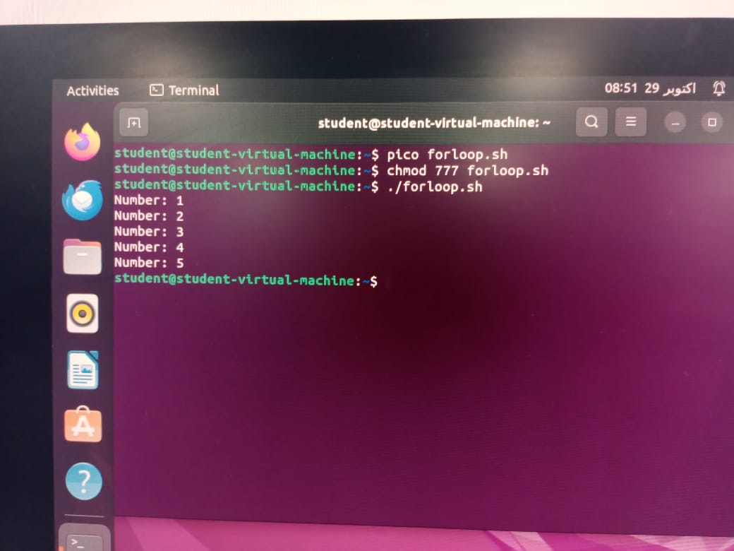

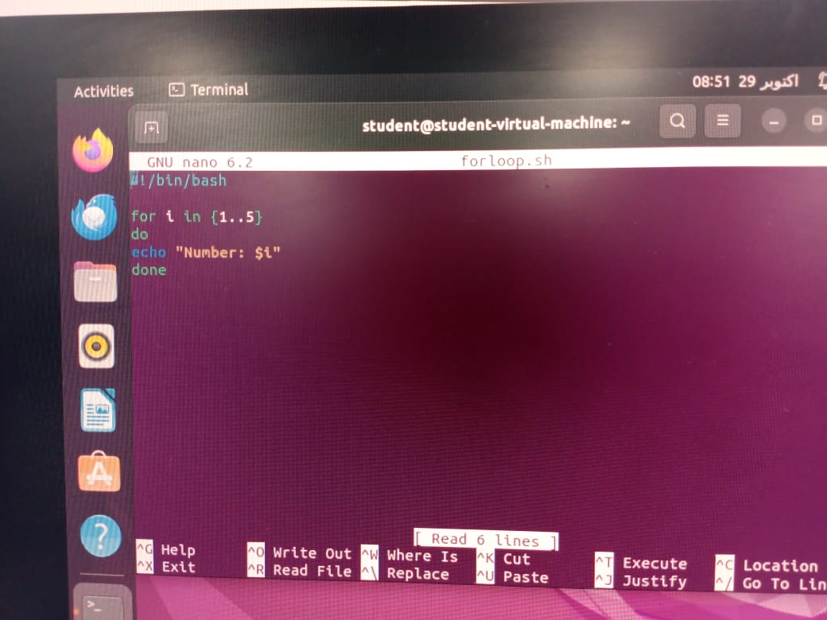

**Q2.** What is the syntax for a while loop that counts from 1 to 10 and prints each number?

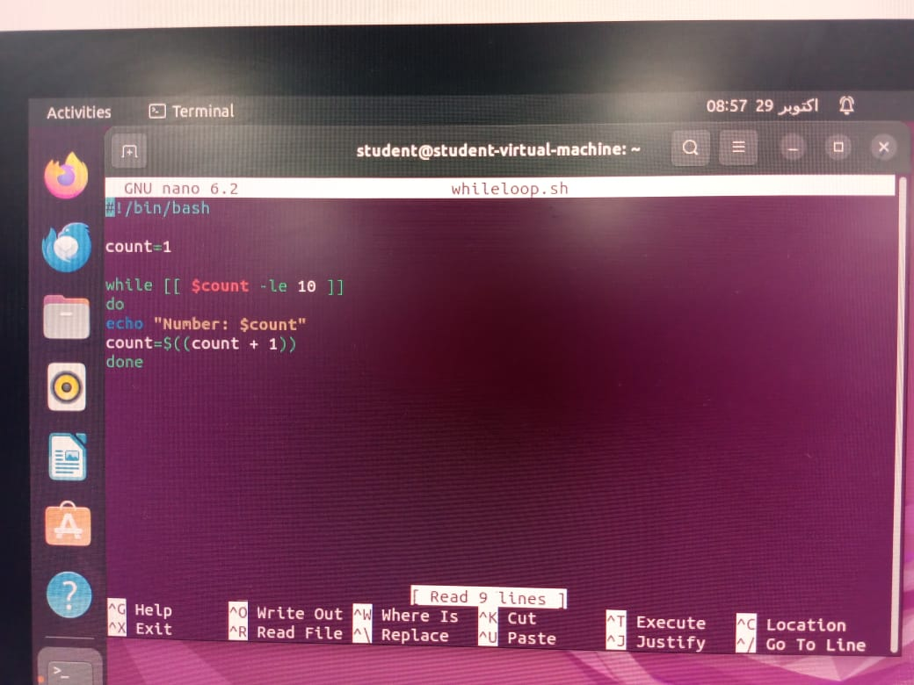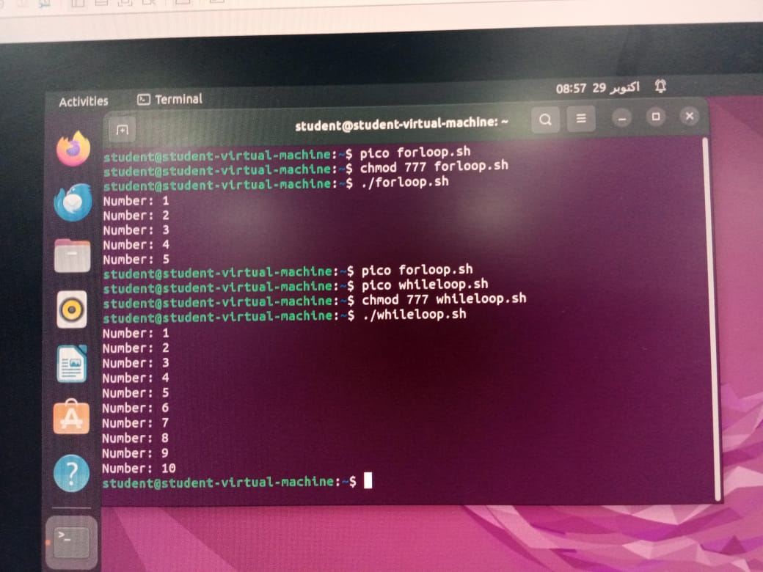

**Q3.** How would you write a nested loop in shell scripting to print a multiplication table from 2 to 3?

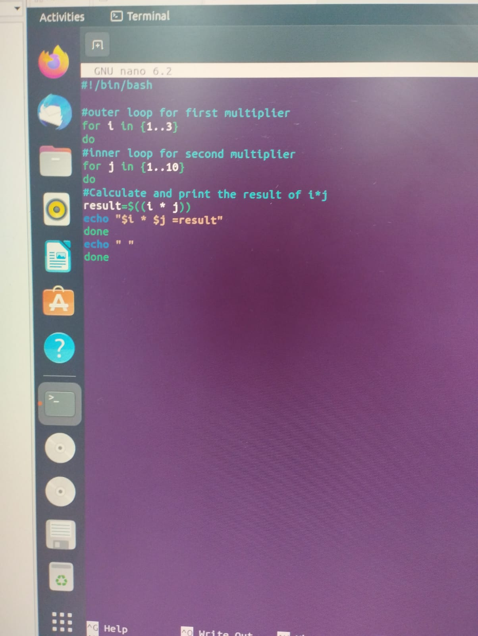

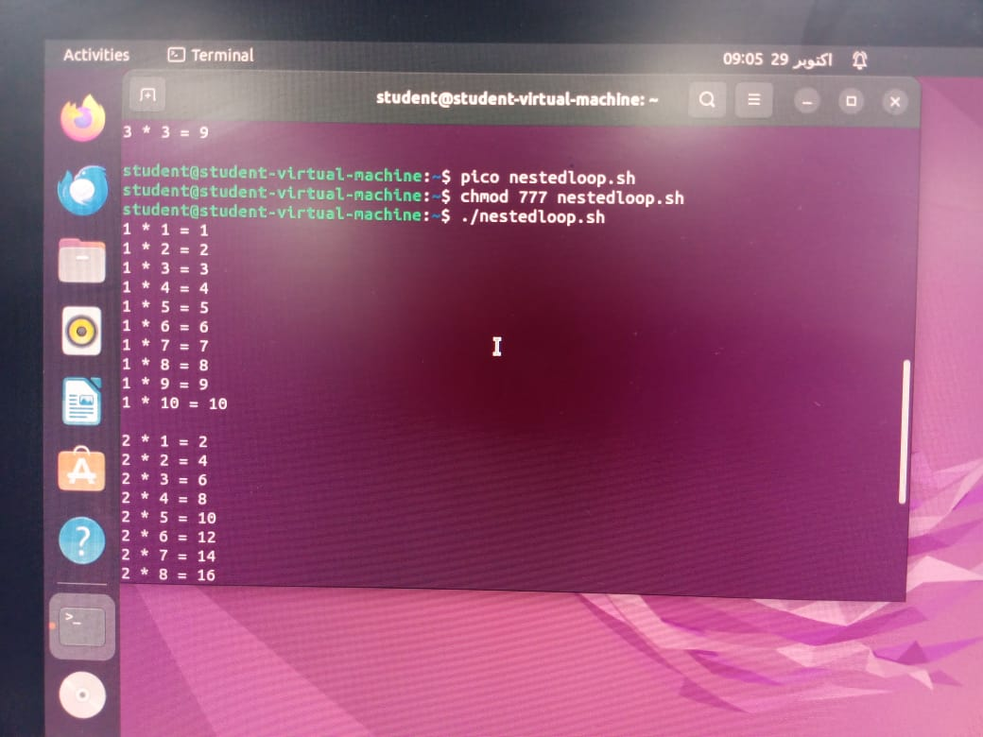

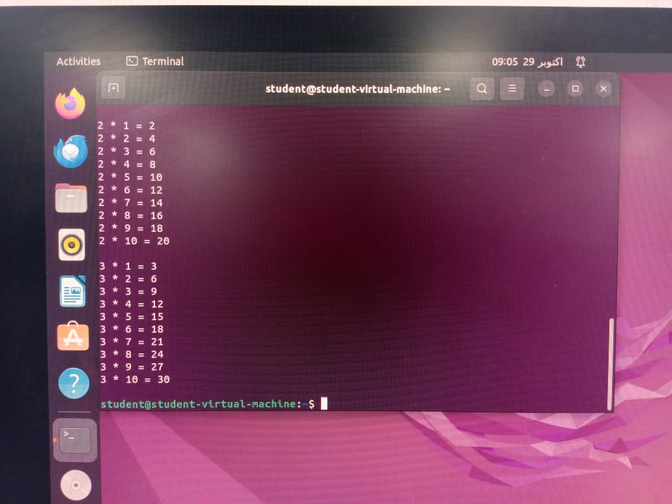

**Q4:** Write a for-in loop that iterates over the items in an array named fruits containing apple, banana, and cherry.

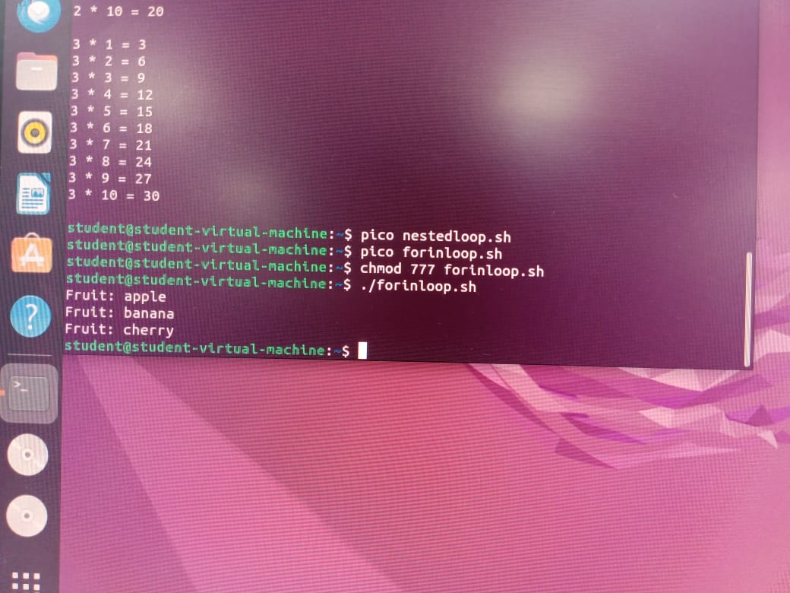

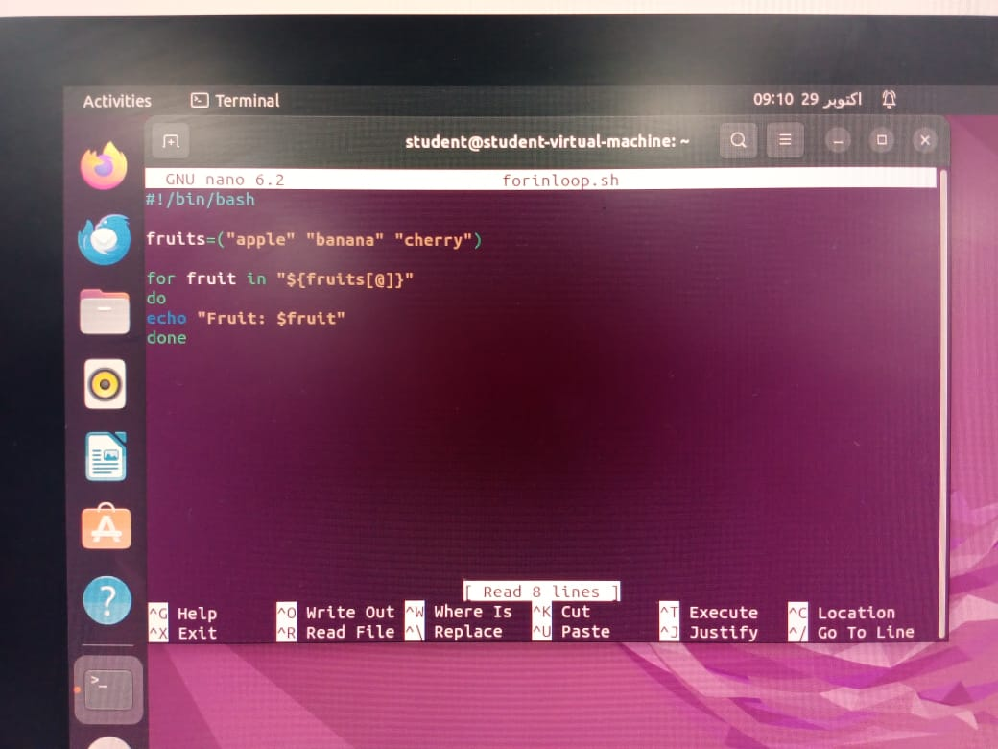

**Q5:** Write a while loop that reads user input until the user types "exit".

